_{Timothy Steven Bukowski}
Phone: 651-706-9733 Email: timothystevenbukowski@gmail.com

_{Education}
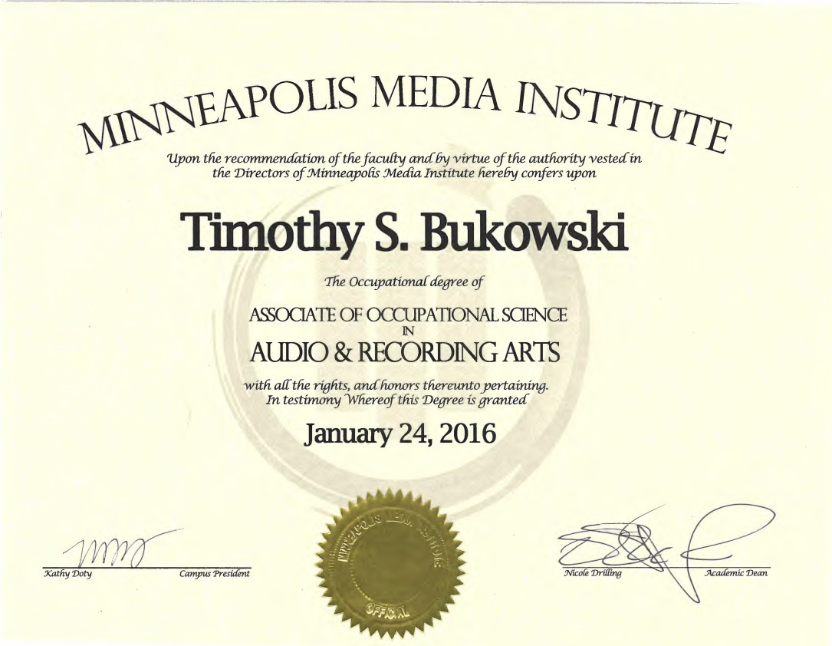

- Associates of Audio & Recording Arts,
From September 2014 - February 2016 at Minneapolis Media Institute
- _{High School Diploma}
From April 2009 - March 2012 at South Saint Paul Secondary

_{Experience}

- _{Audio/Visual Technician}
From May 2022 – Present at Freelance
Set, struck, and operated audio/visual/lighting equipment for live music concerts, theatrical events, comedy shows, and more at Acadia and Eagles 34 in Minneapolis

- _{Audio/Visual Technician}
From May 2022 – May 2025 at Can Can Wonderland in St Paul, MN
Set, struck, and operated audio/visual/lighting equipment for live music concerts, theatrical events, comedy shows, and more
- _{Event Organizer/Booking Agent}
From March 2021 - present at Attainment R.E.M.M.P.P. in Minneapolis MN
Rented venues, contacted and booked bands to perform, rented and operated the sound system and promoted the events
- _{Lead Audio/Visual Technician,}
From January 2018 - July 2018 at PSAV in Austin TX
Led a team of technicians in the setting, striking, and operation of audio/visual/lighting/power equipment for corporate business meetings.
- _{Audio/Visual Technician,}
From February 2016 - December 2017 at PSAV in Minneapolis MN
Set, struck, and operated audio/visual/lighting/power equipment for _{corporate business meetings.}

_{Qualifications:}

- 13+ years experience recording, editing, and mixing audio on various DAWS including Ableton Live, Avid Pro Tools, and Apple Logic Pro.
- 7+ years of experience operating audio/visual/lighting equipment for events such as live music concerts of various styles, corporate business meetings, and theatrical productions.
- Performs efficiently and calmly under pressure, troubleshooting issues as they arise and finding solutions in a timely matter.
- Excellent communication and customer service skills when determining clients' AV needs.

